Peptide Synthesizer (PS3, Protein Technologies)

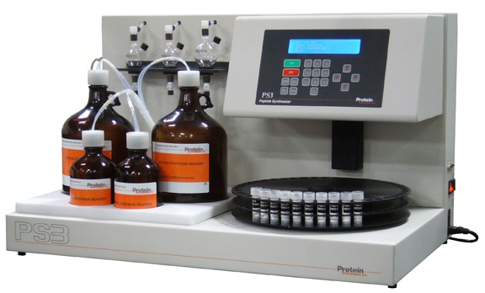

The PS3™ has 3 serial reaction vessels and allows up to 45 couplings without user intervention or reloading. The efficient packaging method for protected amino acids and activator simplifies procedures and reduces the number of mechanical components required.
Specification:
Synthesis Scale: | 0.005 - 1.50 mmol (at 2x excess, up to 1.0 g of resin per RV)
Unattended Couplings: | 45
Reaction Vessels: | Three, glass (2 × 30mL; 1 × 75 mL)
Reagents/Solvents: | Amino acids & activators:  Prepackaged vials (0.4 mmol and 1.0 mmol)
for F-MOC: | 20% Piperidine/DMF: Prepackaged bottles (1L)  0.4M N-Methylmorpholine/DMF:  Prepackaged bottles (1L)  Dimethylformamide or NMP: Bottles (2 × 4L)
for t-BOC: | 50% TFA in methylene chloride (1L)  10% diisopropylethylamine in DMF (1L)  Methylene chloride (2 × 4L)
Fluid Transfer: | Nitrogen or Argon pressure
Solution Removal: | Filtration
Accessories:
- 30mLReactionVessel,Glass
- 75 mL Reaction Vessel, Glass
- Reaction Vessel Cap
- AA Vial, Cap, & Septa
- AA Vial, Cap, & Septa
- Septa for AA Vial
- Septa for AA Vial
- O-Rings for AA Vial
- Bottle, Safety-Coated 1 L
- Bottle, Safety-Coated 4 L
- Bottle Filter Frit, 1/8" Tube
- Bottle Filter Housing, 1/8" Tube
- Insert for 0.5, 1, and 4 L Bottle Caps
- O-Ring for 0.5, 1 and 4 L Bottles
- Filter Washer Set (30 Filters, 10 Washers)
- Waste Tank

Other Supporting Instruments
- Dionex Ultimate 3000 HPLC
- WATERS HPLC
Facilities Available:
- Fmos –Chemistry (All natural/unnatural amino acids, alpha amino acids)
- Resins available (Wang, 2-Chlorotrityl, MBHA-RAM etc.)
- N-terminal protection (Acetylation, Benzylation, Biotinylation, etc.)
- C-terminal modification (methyl, Ethyl, Benzyl esters etc.)
- Disulphide fridges in Cys containing peptides, Cyclization etc.)
- Labeling with dyes (FITC, CongoRed, Cy5, Pyrene, Tamra etc.)

