Laser scanning Confocal Microscope
Nikon - Model AI(R)
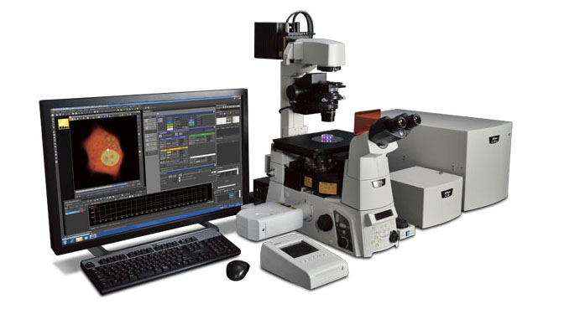
Confocal laser scanning microscopy (CLSM or LSCM) is a technique for obtaining high-resolution optical images with depth selectivity. The key feature of confocal microscopy is its ability to acquire in-focus images from selected depths, a process known as optical sectioning. Images are acquired point-by-point and reconstructed with a computer, allowing three-dimensional reconstructions of topologically complex objects.
Specifications
Laser | Compatible Laser | 405 nm, 440/445 nm, 488 nm, 561/594 nm, 638/640 nm, Ar laser (457 nm, 488 nm, 514 nm), HeNe laser (543 nm)
 | Modulation | Method: AOTF (Acousto-Optic Tunable Filter) or AOM (Acousto-Optic Modulator) device
 |  | Control: power control for each wavelength, return mask, ROI exposure control
 | Laser unit | Standard: LU4A 4-laser module A or C-LU3EX 3-laser module EX
 |  | Optional: C-LU3EX 3-laser module EX (when 4-laser module A is chosen as standard laser unit)
Standard fluorescence detector | Wavelength | 400-750 nm
 | Detector | 4 PMT
 | Filter cube | 6 filter cubes commonly used for a microscope mountable on each of three filter wheels
 |  | Recommended wavelengths: 450/50, 482/35, 515/30, 525/50, 540/30, 550/49, 585/65, 595/50, 700/75
Diascopic detector (Option) | Wavelength | 450-650 nm
 | Detector | PMT
FOV |  | Square inscribed in a o18 mm circle
Image bit depth |  | 4096 gray intensity levels (12 bit)

Scnning head | Standard image acquisition | Scanner: galvano scanner x2
 |  | Pixel size: max. 4096 x 4096 pixels
 |  | Scanning speed:
 |  | Standard mode: 2 fps (512 x 512 pixels, bi-direction), 24 fps (512 x 32 pixels, bi-direction)
 |  | Fast mode: 10 fps (512 x 512 pixels, bi-direction), 130 fps (512 x 32 pixels, bi-direction)^{*1}
 |  | Zoom: 1-1000x continuously variable
 |  | Scanning mode: X-Y, X-T, X-Z, XY rotation, Free line
 | High-speed image acquisition | Scanner: resonant scanner (X-axis, resonance frequency 7.8 kHz), galvano scanner (Y-axis)
 |  | Pixel size: max. 512 x 512 pixels
 |  | Scanning speed: 30 fps (512 x 512 pixels) to 420 fps (512 x 32 pixels), 15,600 lines/sec (line speed)
 |  | Zoom: 7 steps (1x, 1.5x, 2x, 3x, 4x, 6x, 8x)
 |  | Scanning mode: X-Y, X-T, X-Z
 |  | Acquisition method: Standard image acquisition, High-speed image acquisition, Simultaneous photoactivation and image acquisition
 | Dichroic mirror | Low-angle incidence method, Position: 8
 |  | Standard filter: 405/488, 405/488/561, 405/488/561/638, 405/488/543/638, 457/514, BS20/80
 |  | Optional filter: 457, 405/488/543, 457/514/561, 440/514/594
 | Pinhole | 12-256 μm variable (1st image plane)
Spectral detector (with galvano scanner) (Option) | Number of channels | 32 channels
 | Wavelength detection range | 400-750 nm
 | Spectral image acquisition speed | 4 fps (256 x 256 pixels), 1000 lps
 |  | Pixel size: max. 2048 x 2048
 | Wavelength resolution | 80 nm (2.5 nm), 192 nm (6 nm), 320 nm (10 nm)
 |  | Wavelength range variable in 0.25 nm steps
 | Unmixing | High-speed unmixing, Precision unmixing
Z step |  | Ti-E: 0.025 μm, FN1 stepping motor: 0.05 μm
Compatible microscopes |  | ECLIPSE Ti-E inverted microscope, ECLIPSE FN1 fixed stage microscope, ECLIPSE Ni-E upright microscope (focusing nosepiece type and focusing stage type)
Option |  | Motorized XY stage (for Ti-E/Ni-E), High-speed Z stage (for Ti-E), High-speed piezo objective-positioning system (for FN1/Ni-E), VAAS

Accessories:
- Laser Scanning Confocal Microscope AI(R)
- Halogen lamp 12V-100W LL, MXA 20434
- HG F lamp, 85V 120W
- CF I Apochromat TIRFE 60XH NA 1.49
- CF I Apochromat TIRFE 100XH NA 1.49

